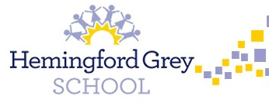

**Mathematics:**

Year 1 children will have a focus on counting and place value to 10. Year 2 children will focus on place value and partitioning numbers.

Children will have opportunities to access a wide range of mathematical concepts through play.

**Music:**

As musicians, children will use their voices expressively and creatively by singing songs and speaking chants and rhymes. They will explore music from different countries.

**Writing:**

As writers, we will continue to put reading at the forefront of our learning and base our literacy around key texts. We will write in different genres and link our writing to our theme where possible.

**PSHE:**

This term we will have a big focus on settling back into school and agreeing rules and expectations. We will look at how to be a good friend and how to build relationships with our peers. We will learn about our emotions.

**Year 1 & 2**