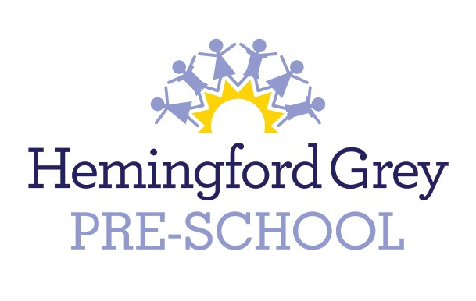
Hemingford Grey Preschool
Policy: Fees

Fees are reviewed annually by the Resources Committee of the school’s governing body and current fees are advertised on the Preschool website. Fee increases are generally considered in the summer term and come into effect on 1st September of the following academic year. All parents are notified in writing of any fee increases.

Fees September 2021 to September 2022
These fees have been agreed by a sub-committee of the Hemingford Grey Primary School Governing Body.

 | Two Year Olds | Three/Four Year Olds
Charges per hour 2021-22  9am-3pm Monday – Friday Term Time only | £5.80 | £5.20
Wrap Around Provision | N/A | £5.50

Hemingford Grey Preschool are in receipt of Early Years Education Funding. When a child qualifies for this funding, (currently the term after their third birthday, or if the child is eligible for the Funded 2s grant), parents will be notified and supplied with the application information. Parents are responsible for applying for Funded 2s grant and 30 hours funding through the government website Childcare Choices. They will be required to complete a Parent/Carer Declaration and supply proof of date of birth and identity, i.e. birth certificate or passport. The Preschool will submit the documentation.

Invoices are sent out half termly via FAMLY. Hot lunch fees are also collected via FAMLY. A payment due date is specified but parents are welcome to pay before the due date. Payments may be made by bank transfer or FAMLY Pay. Payments can also be made using childcare vouchers. Parents may choose to enrol children in additional sessions by checking with staff. Additional session costs will be included in the follow half term invoice. Fees must be paid in full.

In the case of emergency closure fees will still be charged in full.

If a parent / carer decides to terminate their agreement, Preschool requires a half term notice period.

In cases of financial hardship, there may be assistance from the Langley Trust, a village charity dating back to the mid-seventeenth century. Requests for assistance are treated in confidence and can be made to the trustees of the charity, whose names and contact details can be found on public notice boards in the village.

Outstanding or Overdue Fees

If fees are not made by the initial deadline, a reminder will be sent giving two further weeks to pay. The reminder will be sent via our FAMLY system.

If, after the 2 week grace period fees have not been paid, with no communication from parents/carers to the Preschool Manager or school Finance Administrator, a fee of 5% (minimum of £10) of the total outstanding fees will be added to the invoice.

The invoice will be sent out via FAMLY, a paper copy will also be handed to parents with a due date of 1 month after the initial deadline.

If after the second reminder fees are still outstanding with no communication the headteacher will contact the parent/carer in writing.

A warning will be given that if payment is not received within one week, Playgroup reserves the right to refuse childcare (over and above the funded 15 hours or 30 hrs).

In the event that payment is still not received, the committee reserves the right to take legal action to recover the fees.

This policy was adopted at a Hemingford Grey Governing Body Resources Committee, held on 19th October 2021

