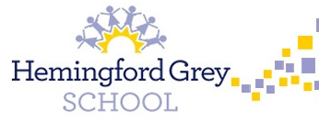

**Mathematics**

We will continue to develop our mathematical fluency, problem solving and reasoning skills through exploring different mathematical concepts.

**PSHE**

We will explore how to work together effectively and the skills needed to collaborate. In addition, we will explore what it means to be financially capable.

**Music**

As musicians, we will learn to listen, appraise and preform a range of songs. Our focus will be on how Music Connects Us with Our Past. ***Key Influencers: Martha and the Vandellas***

**Writing**

As writers, we will develop our understanding of a range of text types including narratives and non-fiction using different stimulus. We will continue to explore sentence stacking to develop a deeper understanding of grammar and punctuation and how these are used to create impactful texts.

**Year 5 & 6**