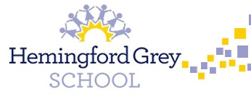

**PSHE**

In PSHE, we will be exploring how we maintain a healthy lifestyle. As well as physical health, we will be looking at our emotional wellbeing and mental health. We will also learn about our sense of personal identity and self-worth and how to consider and respect the needs and views of others.

**Mathematics**

Children will be focusing on developing their fluency skills in the 2’s, 5’s and 10 times tables along with developing a secure understanding of multiplication and division.

**Music**

As musicians, through exploring the question, How Does Music Tell Stories About the Past, we will continue to develop our skills in singing, listening, playing, improvising and composing.

**Writing**

As writers, we will continue to put reading at the forefront of our learning and base our literacy around key texts like *Ruby’s Worry* and *The Day The Crayons Quit*. We will explore a range of genres and provide opportunities for lots of discussion and role play. KS1 writing skills will be taught across the year.

**Year 1 & 2**