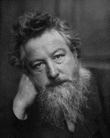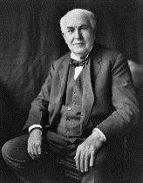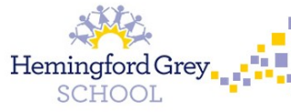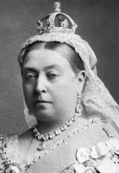

**Why was the Victorian era so important to the modern World?**

**Physical Education**

We will be playing tag rugby, using skills, strategies and tactics to outwit the opposition. We will also be keeping fit with Boogie Bounce!

**French**

As linguists, we will be learning to answer questions about where we live, how we get to school and we will be using directions in French.

**Music**

We will celebrate a wide range of musical styles: Listening, Singing, Playing Composing and Performing, reflecting on the question: How does music bring us closer together?

**Religious Education**

**We will explore the following questions: Would celebrating Diwali at home and in the Community bring a feeling of belonging to a Hindu child?**

**Has Christmas lost its true meaning?**

***Key Influencer: Rishi Sunak***

**Art**

As artists, we will be exploring and developing ideas based on the artwork of William Morris.

***Key Influencer: William Morris***

**DT**

As designers, we will be designing a circuit board game using our electrical knowledge acquired from science. We will evaluate our product against original design criteria.

**History**

As historians, we will be looking at the main events of Queen Victoria’s reign. We will be discussing the changes that happened during the Victorian era and the impact this era had on our lives today.

***Key Influencer: Queen Victoria***

**Key: Queen Victoria**

**Science**

As scientists, we will be exploring two different topics: forces and magnets & electricity. We will be taking part in practical investigations, comparing our test results and drafting detailed annotated diagrams.

***Key Influencer: Thomas Edison***

**Year 3 & 4**

**PSHE**

As part of our personal development, we will be looking at what gives us a sense of belonging and how we can become good citizens.

**Computing**

As computer technicians, we will be developing our understanding of the world wide web and how to stay safe on line.

***Key Influencer: Tim Berners Lee***